

EDINGTON
PARISH COUNCIL
RISK REGISTER

Register Update Timeline
- Version: 1.0
- Adopted: 10 August 2026
- Adopted by: Full Council
- Published: 12 August 2026
- Review Due: Feb/March 2027

Introduction
This Risk Register for Edington Parish Council identifies, evaluates, and proposes controls for key operational, financial, and strategic risks.
Risk Assessment Methodology
Risks are scored based on their Likelihood (1-5) and Consequence/Impact (1-5). The Council uses a 5x5 matrix to track and address risks based on the 4Ts of risk response: Terminate; Treat; Transfer; Tolerate. Risks scoring 8 and above require detailed consideration and a specific action plan.
- Likelihood: 1 (Rare) to 5 (Highly Likely/Common).
- Consequence: 1 (Insignificant/Negligible) to 5 (Catastrophic/Severe).
- Risk Score: Likelihood x Consequence.
Edington Parish Council Risk Register
Risks are reference categorised in the register as:
1 – Parish Council administration and operational risks
2 – Financial risks
3 – Governance risks
4 – Public safety risks
Ref | Risk Description | L | C | Score | Controls & Mitigation | Response
1.1 | Loss of Clerk/Staff  Interruption to administration or missing key dates. | 3 | x3 | 9 | Use of locum panels (SLCC/WALC); Councillors trained in basic admin/finance; succession planning. | Treat
1.2 | IT/Data Loss  System fault or loss of information on Clerk/Chair laptops. | 3 | x3 | 9 | Regular backups to the cloud/physical storage; use of anti-virus software; annual testing of restore process. | Treat
2.1 | Financial Fraud  Missing funds due to fraud by staff or members. | 2 | x3 | 6 | Robust Financial Regulations; regular bank reconciliations; Insurance. | Treat
2.2 | Budgeting/Precept  Incorrect precept leading to insufficient or excess reserves. | 3 | x3 | 9 | Robust and timely budgeting process; monitor reserves, timely submission of bids for funds. | Treat
3.1 | Public Liability  Injury to third parties from Council assets. | 3 | x4 | 12 | Maintain Public Liability Insurance (£10m+); annual safety inspections; up-to-date asset register. | Transfer
3.2 | GDPR/Data Breach  Failure to comply with data protection or retention policies. | 3 | x3 | 9 |  | Treat
  Adopt Data Protection and Retention & Disposal policies; use a filing and retrieval system; regular policy reviews, training.
3.4 | Member Interests  Lack of transparency regarding Councillor interests. | 2 | x3 | 6 | Review declarations annually; "Declaration of Interests" as a standing agenda item; record declarations in minutes. | Treat
4.1 | Play Field and Equipment  Injury or damage as the result of using Council Play Field and Play Equipment | 3 | x4 | 12 | Ensure all equipment is inspected in accordance with best practice schedules, weekly, quarterly and annually. Ensure budget is available to carry out all maintenance promptly. Ensure equipment is compliant with British Standards at time of manufacture. Ensure adult supervision is recommended for all children using the facility. Ensure that all insurance is up to date and carries sufficient public liability (£10m+). | Treat & Transfer
4.2 | Tree Safety  Injury or damage from trees on Council land. | 2 | x4 | 8 | Annual asset condition report; photographic records; budgetary provision for repairs; maintenance schedules. | Treat & Transfer
4.3 | Emergency Planning | 1 | x5 | 5 | Annual asset condition checks, review of the plan each year. | Treat
Management and Review
- Risk Control (The 4 Ts): The Council will manage risks by Terminating (eliminating the cause), Treating (reducing impact/likelihood), Transferring (insuring or sharing), or Tolerating (accepting) the risk.
- Review Cycle: The Risk Strategy should be reviewed annually by the Council. The Risk Register is a working document and should be reviewed at least quarterly or whenever new risks emerge.
- Transparency: The Strategy and Register will be published on the Council’s website in accordance with the Freedom of Information Act 2000.

The Risk Assessment Framework  Consequence | The 4 Ts of Risk Response  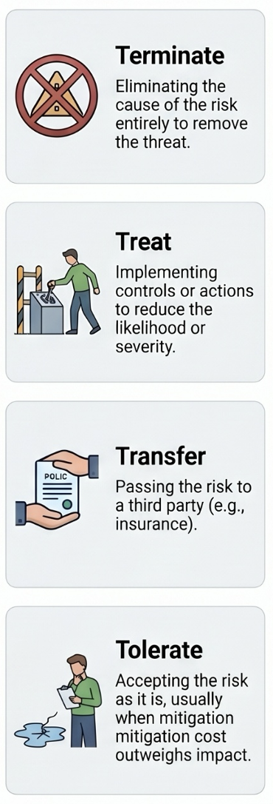
  Likelihood | 5: Highly Likely | 5 |  | 10 | 15 |  | 20 |  |  | 25
  Likelihood | 4: Likely | 4 |  | 8 | 12 |  | 16 |  |  | 20
  Likelihood | 3: Possible | 3 |  | 6 | 9  1.1 Loss of Clerk/Staff  1.2 IT/Data Loss  2.2 Budgeting/Precept  3.3 GDPR Data Breach |  | 12  3.1 Public Liability  4.1 Playfield Equip |  |  | 15
  Likelihood | 2: Unlikely | 2 |  | 4 | 6  2.1 Financial Fraud  3.4 Member Interests |  | 8  4.2 Tree Safety |  |  | 10
  Likelihood | 1: Rare | 1 |  | 2 | 3 |  | 4 |  |  | 5  4.3 Emerg Planning
  Likelihood |  | 1: Insignificant | 2: Minor |  |  | 3: Moderate |  | 4: Major | 5: Catastrophic
  
  Scores of 8 and above require detailed consideration and a formal action plan.
  Scoring Methodology
  Score = Likelihood (1-5) × Consequence (1-5)
  Annual Review Cycle
  The Risk Strategy is reviewed annually by the Full Council, and the Register is updated quarterly or as new risks emerge.

