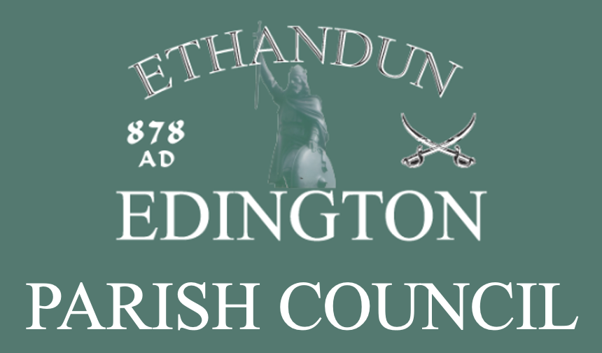

EDINGTON
PARISH COUNCIL
STATEMENT OF INTERNAL CONTROL

Statement of Internal Control Update Timeline
- Version: 1.0
- Adopted: 14 September 2026
- Adopted by: Full Council
- Published: 14 September 2026
- Review Due: May 2027

Table of Contents
Statement of Internal Control Update Timeline 1
1. SCOPE OF RESPONSIBILITY 3
2. THE PURPOSE OF THE SYSTEM OF INTERNAL CONTROL 3
3. THE INTERNAL CONTROL ENVIRONMENT 3
4. REVIEW OF EFFECTIVENESS 4
5. SIGNIFICANT INTERNAL CONTROL ISSUES 4
6. EXTERNAL AUDIT 5
7. APPROVAL 5
ANNEX A – INTERNAL CONTROL CHECKLIST 6

1. SCOPE OF RESPONSIBILITY
Edington Parish Council (The Council) is responsible for ensuring that its business is conducted in accordance with the law and proper standards, and that public money is safeguarded and properly accounted for, and used economically, efficiently, and effectively. In discharging this overall responsibility, The Council is also responsible for ensuring that there is a sound system of internal control as required by Section 2 of the Annual Return, which is in Section 1, page 4 of the Annual Governance Statement.

2. THE PURPOSE OF THE SYSTEM OF INTERNAL CONTROL
The system of internal control is designed to manage risk to a reasonable level rather than to eliminate all risk of failure to achieve policies, aims and objectives; it can therefore only provide reasonable and not absolute assurance of effectiveness.
The system of internal control is based on an ongoing process designed to identify and prioritise the risks to the achievement of The Council’s policies, aims and objectives; evaluating the likelihood of those risks being realised and the impact should they be realised; and managing them efficiently, effectively and economically. It was adopted by The Council for the year ended 31 March 2027. Up to the date of approval of the annual report and accounts, and except for the details of significant internal control issues at section 5, it accords with proper practice.

3. THE INTERNAL CONTROL ENVIRONMENT
The Council: The Council has appointed a Chairperson, who is responsible for the running of meetings and for ensuring that all Council decisions are lawful. The Council reviews its obligations and objectives, approves budgets and sets the level of precept at a full council meeting in the January of each financial year. The Full Council meets at least 11 times each year and monitors progress against its aims and objectives and actions to achieve them at each meeting. The Council carries out regular reviews of its internal controls, systems, and procedures.
Clerk to the Council: The Council has appointed a Clerk to the Council who acts as the Council’s advisor and administrator. The Clerk has a contract of employment with clear terms and conditions, and their salary is approved by the Council. The Clerk will be responsible for the day-to-day compliance with laws and regulations that The Council is subject to, and for managing risks. The Clerk will also ensure that The Council’s procedures, control systems and polices are adhered to.
Responsible Financial Officer: The Clerk is also the Council’s Responsible Financial Officer and is responsible for administering the Council’s finances. The Council has adopted the Model Financial Regulations as recommended by NALC.
Code of Conduct: Each Council member must sign Acceptance of the Code of Conduct and complete a Register of Interest form. Members consider every item on the agenda and ensure that any interests are declared at the beginning of the meeting or before the matter is discussed. An item ‘Declarations of Interest’ will be placed on every agenda.
Asset Register: The Council maintains a register of all material assets owned or in its care. The Clerk updates this as and when necessary, and it is approved annually.
Payments: All payments are reported to The Council for approval. Every payment is authorised by two nominated Members of The Council. VAT payments are identified, recorded and reclaimed by the Clerk. Remembered or saved passwords facilities must not be used on any computer used for council banking work, and passwords must be changed regularly.
Income: All income is received and banked in The Councils’ name in a timely manner and reported to the Council.
Risk Assessments / Risk Management: The Council carries out regular risk assessments in respect of its actions and regularly reviews its systems and controls.
Insurance: The Council’s insurance provision is reviewed annually both in relation to its schedule of cover and its value for money.
Internal Control Checklist: The Council’s Internal Control Checklist is at Annex A.
Internal Audit: The Council has appointed an Independent Internal Auditor who reports to The Council on the adequacy of its:
- Records
- Procedures
- Systems
- Internal control
- Regulations
- Risk management
- Reviews
The effectiveness of the internal audit system is reviewed annually.
External Audit: The Council’s External Auditor, PKF Littlejohn LLP, submit an annual Certificate of Audit to The Council, which is presented to The Council.

4. REVIEW OF EFFECTIVENESS
The Council has responsibility for conducting an annual review of the effectiveness of the system of internal control. The review of the effectiveness of the system of internal control is informed by the work of:
- The Full Council.
- The Clerk to the Council/Responsible Financial Officer who has responsibility for the development and maintenance of the internal control environment and managing risks.
- The independent Internal Auditor who reviews The Council’s system of internal control.
- The Council’s external auditors make the final check using the Annual Return; a form completed and signed by The Responsible Financial Officer, The Chairman and the Internal Auditor; and issue an annual audit certificate.
- The number of significant issues that are raised during the year.

5. SIGNIFICANT INTERNAL CONTROL ISSUES
No significant internal control issues, apart from the absence of some formal documentation, were identified during the financial year ended 2026.
The Internal Auditor’s report was accepted at The Full Council Meeting on 23 June 2026.
Whilst no significant internal control issues, apart from formal documentation and minuting, were identified during the year, The Council strives for the continuous improvement of the system it has adopted for internal control and has addressed any minor issues and weaknesses raised and reported during the review process.

6. EXTERNAL AUDIT
When the external audit report is received it will be reviewed and considered at the council meeting following its receipt, and any points raised will be addressed.

7. APPROVAL
This Statement of Internal Control shall be approved and amended as necessary at the Annual Parish Council meeting each year.

ANNEX A – INTERNAL CONTROL CHECKLIST

