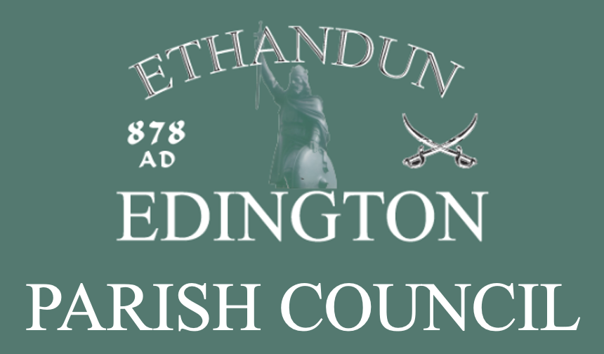
EDINGTON
PARISH COUNCIL
FOI PUBLICATION SCHEME

FOI Publication Scheme Update Timeline
- Version: 1.0
- Adopted: 14 September 2026
- Adopted by: Full Council
- Published: 14 September 2026
- Review Due: Feb/March 2027

1. INTRODUCTION AND COMMITMENT
This scheme commits Edington Parish Council to making information available to the public as part of its normal business activities. The Council commits to:
• Proactively publishing or making available routine information (including environmental information) that falls within the classifications below.
• Specifying the information held that falls within these classifications.
• Publishing the methods by which specific information is made available so it is easily identified.
• Reviewing and updating information on a regular basis.
• Producing a schedule of fees for information access.
• Making this publication scheme itself available to the public.
2. CLASSES OF INFORMATION
The Council will provide information in the following seven classes:
1. Who we are and what we do: Organisational information, locations, contacts, and constitutional/legal governance.
2. What we spend and how we spend it: Financial information relating to income, expenditure, tendering, procurement, and contracts.
3. What our priorities are and how we are doing: Strategy, performance plans, assessments, and reviews.
4. How we make decisions: Policy proposals, decision-making processes, and consultations.
5. Our policies and procedures: Protocols for delivering functions and responsibilities.
6. Lists and registers: Information held in statutory registers and other lists.
7. The services we offer: Advice, transactions, and media releases.
Note: This generally excludes information protected by law (e.g. Freedom of Information Act exemptions), draft documents, or archived files that are difficult to access.
3. HOW TO ACCESS INFORMATION
• Website: Information will be provided on the Council’s website whenever possible at www.edingtonwiltsparishcouncil.gov.uk
• Alternative Methods: If information is not on the website, or if a member of the public cannot access it there, the Council will provide instructions on how to obtain it by other means.
• In Person: In exceptional circumstances, some information may only be available for viewing in person by appointment.
• Accessibility: The Council will adhere to disability and discrimination legislation when providing information in various formats.
4. SCHEDULE OF CHARGES
The Council aims to provide information at minimum cost.
• Website downloads: Free of charge.
• Disbursements: Charges may be made for actual costs such as photocopying, postage and packaging, or costs directly incurred during an in-person viewing.
• Statutory Fees: Charges may be applied where specified by Parliament or legally authorised.
• Notice: If a charge applies, the Council will confirm the payment due before providing the information.
5. INFORMATION TO BE PUBLISHED
Class Information Type Method of Access
Class 1: Who we are Who’s who on the Council/Committees
Contact details for the Clerk and members
Council office location. Website
Class 2: Spending Annual return and auditor report
Finalised budget and precept
Financial regulations
Grants given/received
Members’ allowances. Website
Class 3: Priorities Annual Report to Parish Meeting Website
Class 4: Decisions Timetable of meetings, Agendas, Minutes
Reports presented to meetings
Responses to planning applications. Website
Class 5: Policies Standing orders, Code of Conduct, all council
Policies Website
Class 6: Registers Assets Register
Register of members’ interests
Register of gifts and hospitality. Website
Register of Burials Hard Copy
Class 7: Services Burial Ground and the playing field Website/Hard Copy
6. WRITTEN REQUESTS
Information held by the Council that is not published under this scheme can be requested in writing. Such requests will be considered in accordance with the Freedom of Information Act.

